
CHAUFFER DRIVE AIRPORT TRANSFER RATES

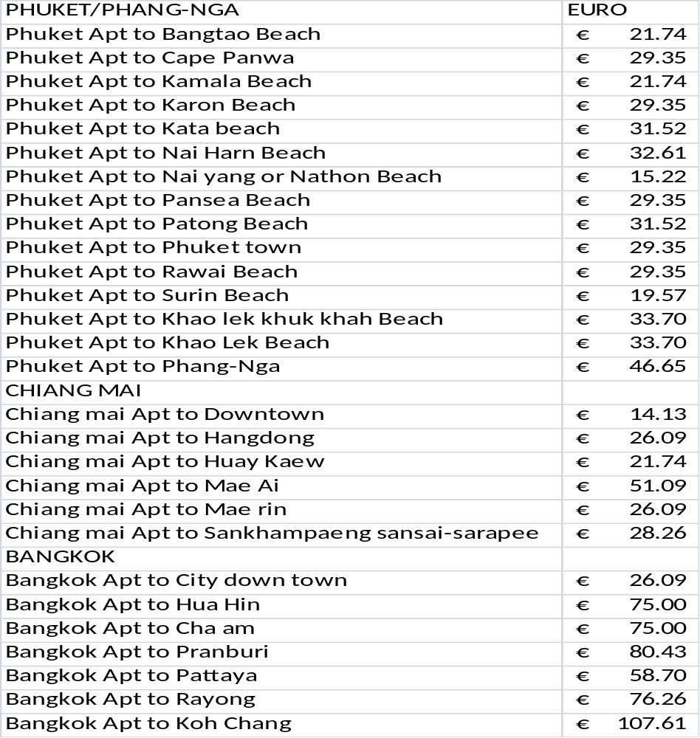
THESE RATES ARE FOR EACH VEHICLE, A MAXIMUM OF 8 PERSONS & LUGGAGE.
We use Toyota Camry saloons or similar for 1 or 2 people & Toyota commuter minibuses for 3 to 8 people. 2 people sharing with extra luggage ie; golf bags may request a minibus for added comfort.

